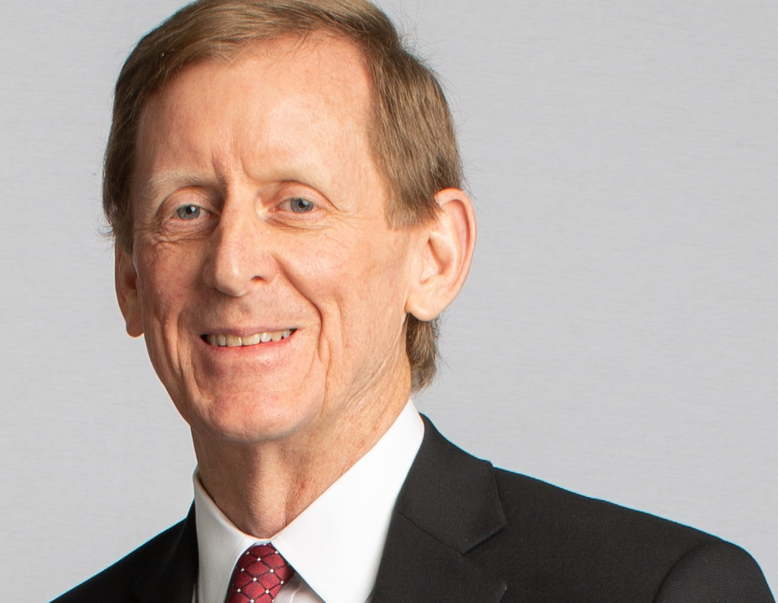

Steve McNeal
Vice President and Treasurer,
Entergy Corporation

Steve McNeal oversees Entergy’s trust investments, corporate finance, risk management, and cash management.

McNeal joined Entergy in 1982 and has held positions in financial planning, corporate finance, risk management and treasury. His experience with Entergy and its subsidiaries includes structuring corporate, project and acquisition financings, directing rating agency relations, managing Entergy’s insurance programs, testifying in regulatory proceedings, overseeing debt compliance and risk engineering, supervising commodity and credit risk management, and managing the investment of pension and decommissioning trust assets.

He holds a bachelor of science in history and business from Trinity University, San Antonio, Texas and a master of business administration from Tulane University.

